**Using Agisoft Metashape to generate Mosaics and DEMs from geotagged VIS, IR and Multispectral UAV Imagery.**

Originally Written by Scott Nowicki

Updated by Ari Koeppel, Nov 2022

**Overall Work flow for FLIR imagery:** Set brightness and contrast -> Align Photos (40,000, 9,000)->View tie points->select and delete all tie points that are erratic->Reset alignment on wildly off photos->delete poor quality photos->align non-aligned photos (again) ->select and delete all tie points that are erratic->Reset alignment on wildly off photos->Optimize cameras (don't check boxes below)-> align or delete unaligned photos again-trim tie points again->optimize cameras again->delete any remaining poorly aligned photos->build dense cloud low quality-> build DEM->build orthomosaic.

Requires an active version of [Agisoft](http://www.agisoft.com/downloads/request-trial/) Metashape.

A tutorial for completing a basic project using Agisoft can be [downloaded here](http://www.agisoft.com/pdf/PS_1.3%20-Tutorial%20(BL)%20-%20Orthophoto,%20DEM%20(GCPs).pdf). This tutorial will show how to generate a spectral cube from multiple imaging systems, appropriate for multispectral analysis.

Micasense Porcessing: [MicaSense RedEdge MX processing workflow (including Reflectance Calibration) in Agisoft Metashape Professional : Helpdesk Portal (freshdesk.com)](https://agisoft.freshdesk.com/support/solutions/articles/31000148780-micasense-rededge-mx-processing-workflow-including-reflectance-calibration-in-agisoft-metashape-pro)

DJI P4 Multispectral is similar

**Correcting Micasense Vignetting, which may be the source of mosaic row striping:** [Radiometric Calibration Model for MicaSense Sensors – MicaSense Knowledge Base](https://support.micasense.com/hc/en-us/articles/115000351194-Radiometric-Calibration-Model-for-MicaSense-Sensors)

Also see: [Best practices: Collecting Data with MicaSense Sensors – MicaSense Knowledge Base](https://support.micasense.com/hc/en-us/articles/224893167-Best-practices-Collecting-Data-with-MicaSense-Sensors)

**Part 1. Starting with the DJI RAW imagery:**

1. **Add Photos** or **Add Folder** from the Workfow menu

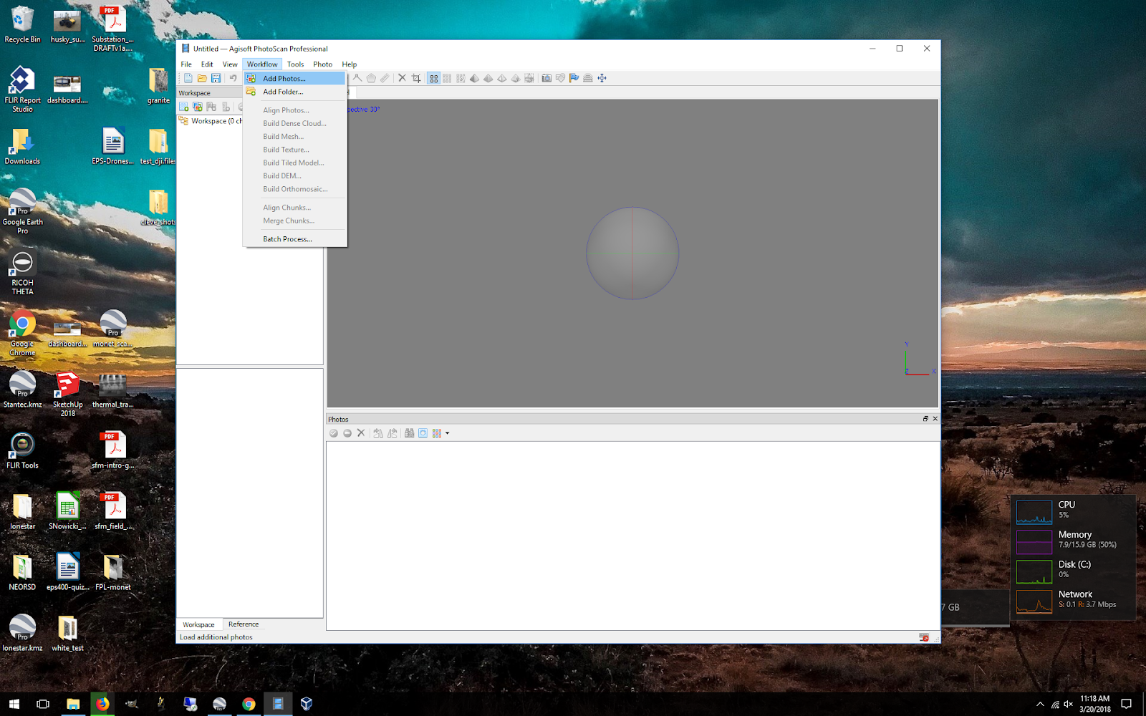

If your images have geotagged positions (stored in the EXIF) then the lat, lon and altitude will automatically be loaded into the Reference dialogue. Images collected by DJI integrated cameras will have EXIF location information. Unless installed separately, FLIR Vue imagery will not have GPS data and needs to be given that info before importing into Agisoft. See <https://github.com/NAU-PIXEL/PSTAR/blob/main/FLIR_Rjpg_read_geo_aligntoDJI.m> for a routine that aligns FLIR imagery to DJI imagery taken contemporaneously.

**Calibrate Reflectance For Multispectral**

If you took images of a calibration target, Agisoft should recognize and isolate those images. If not, you will have to locate one by hand and make an roi of the target (tools>calibrate reflectance>locate panels) + click use sun sensor if you had one on board. Once a panel has been identified, select a proper reference spectra for that panel (tools>calibrate reflectance>select panel…>load). For the micasense panel PIXEL lab has use the following:

**work\common\UAV\MicaSense\RP04-1908101-SC.csv**

**Set Brightness For Multispectral and FLIR (this influences Agisoft’s ability to align)**

Double click a representative image to have it on the view screen.

Tools>Set Brightness>Estimate>OK ….. You may have to toy around with brightness and contrast to get a stretch you like.

**Delete bad images**: If the camera was unstabilized or produced some very noisy images, you may want to remove blurry or bad images before alignment because they can potentially throw off the overall alignment.

2. **Align Photos** from the Workflow menu. For most field collects, a key point limit of 40,000 and tie point limit of 9,000 are good starting values. Make sure “reference preselection” and “exclude stationary tie points” are checked. For stabilized imagery, you typically do not want to use an adaptive camera model. For unstabilized rolling shutter imagery, adaptive may work better. This step may take a long time depending on the number of pictures and degree of overlap. Reducing the accuracy may speed up this step. For good DEMs you want the highest accuracy. For FLIR mosaics, accuracy/resolution is less important.

3. **Import GCPs or Place Markers.** If you collected GCPs with a GPS, use a spreadsheet of locations to create markers. If you are using Google Earth to select GCP’s (and therefore not creating a peer reviewable project) the best way to do this is by creating a CSV of GCPs (gcp name, latitude, longitude, altitude) and importing them into the project.

4. **Optimize Cameras** from the Tools menu.

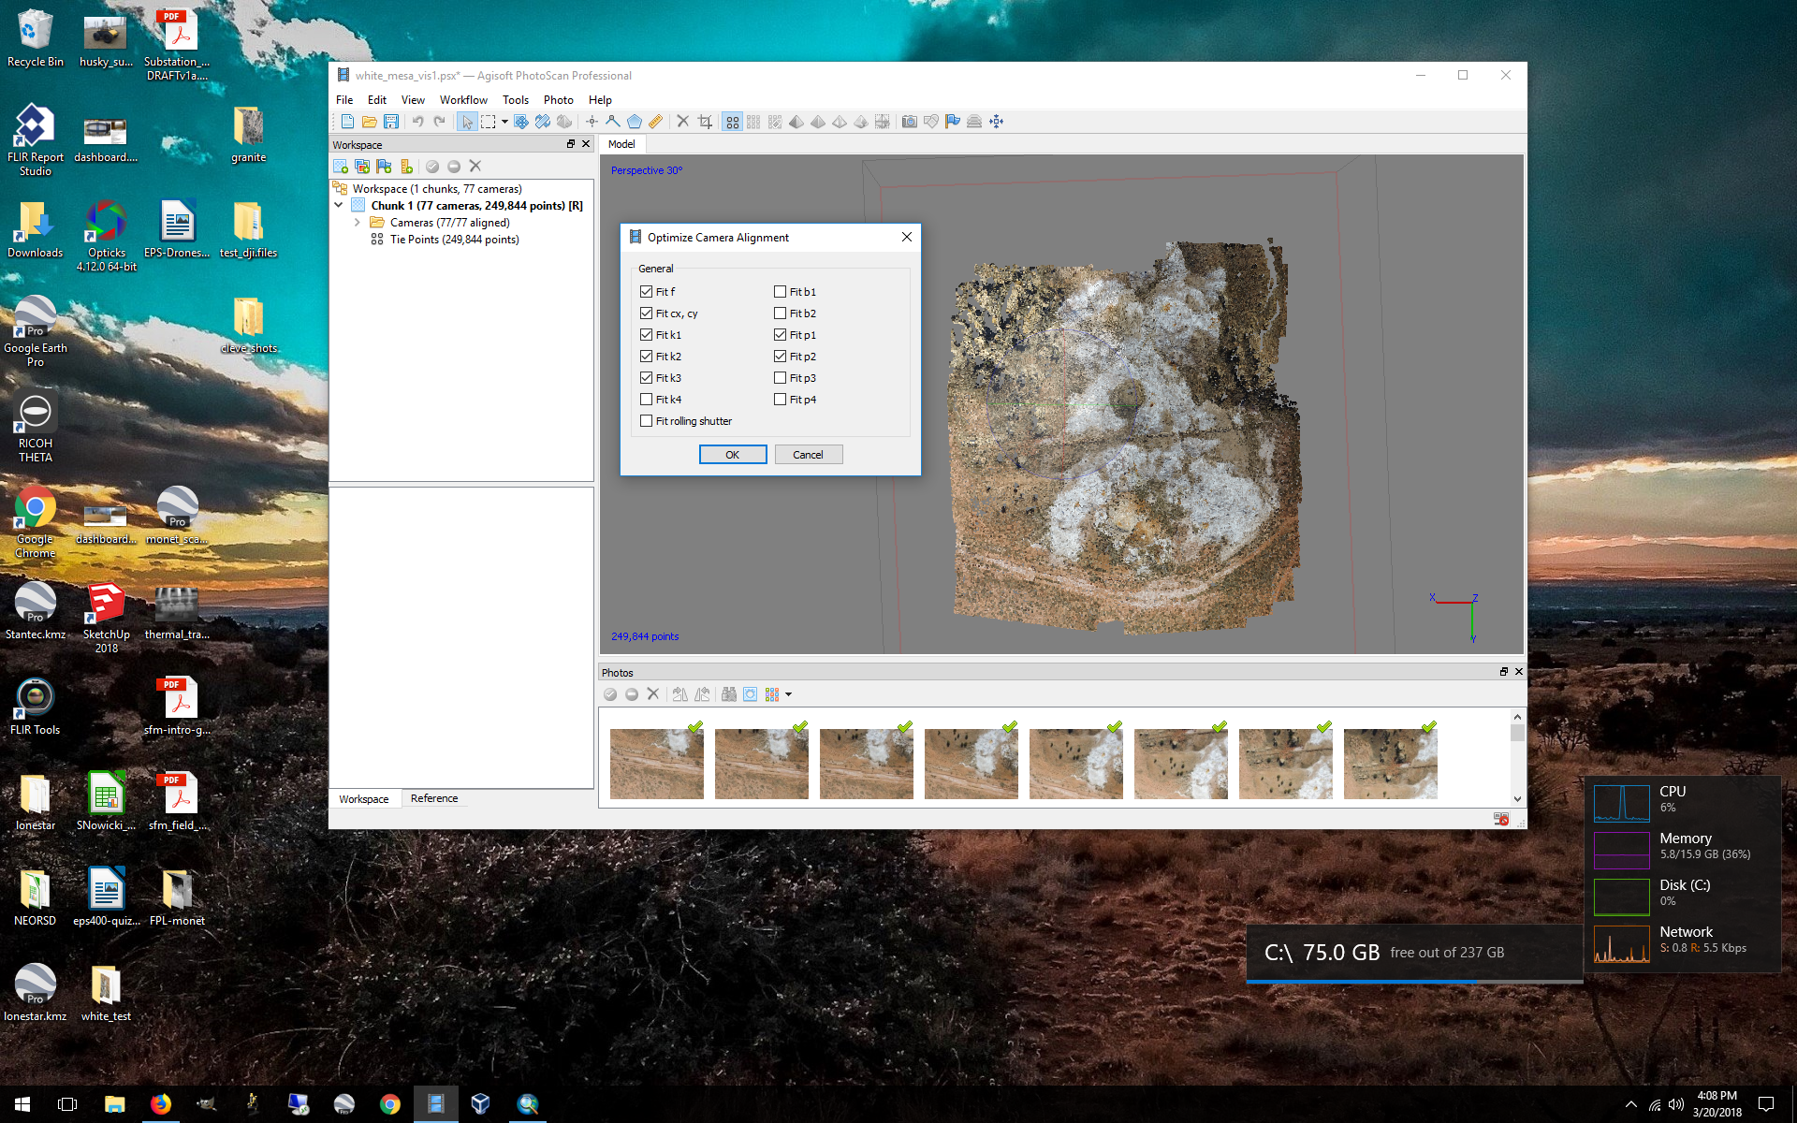

**KEY** After the photos have been re-aligned, you may need to edit the point cloud by removing points that are obviously erroneous. See the tutorial for more information. You may also want to reduce the bounding box to your area of interest, and cut out portions of the point cloud that are projected outside your AOI. For FLIR imagery, you may have to do several rounds of A. Align photos, B. Optimize Photos, C. Manually delete bad points from the point cloud D. Repeat.

 -->  It’s easiest to delete points by using the selection tool. Change from rectangular to free form. Highlight points in pink. Then hit delete.

**IF alignment is still poor** after many go arounds. Sorry. This means the mapping region is very homogenous and you potentially have a lot of work ahead. Your only option here is to add tie points by hand to each image that didn’t align properly (and to some that did align for reference). Open image, right click, “add marker” or “place marker” and select the tie point you placed in another image. To align well, each image needs at least 3 markers that have also been placed in at least one image that is already aligned. Once the markers are placed, right click the image name in the workspace and click align. Do this for all unaligned images.

5. **Build Dense Cloud** from the Workflow menu. Once you are happy with the sparse cloud build the dense cloud (highest resolution if wanting good DEMs, worse resolution if you are doing FLIR mosaics). The quality will affect processing time. For solid surfaces, use depth filtering. For non-solid objects (tree canopies or complex 3d structures), use little to no depth filtering.

6. **Build a DEM** using the dense cloud. Depending on what you are trying to do, you probably want to leave the DEM in geographic (WGS84) coordinates rather than in a projected coordinate system. Export the DEM in the projection you like. If you plan on making a shaded relief map with this DEM, you need to use a projected coordinate system (UTM, etc), otherwise your GIS won’t know where the sun is (you’ll see what the problem is when you try to do this).

7. **Build Orthomosaic** from the Workflow Menu.

You can choose the projection, resolution, and surface (DEM or Mesh) to project to. Starting with the defaults is a good choice.

8. **Output your orthomosaic** by right-clicking on the Orthomosaic layer in the workspace window, Save mosaic as a geotiff, or you can generate a kmz for googling.

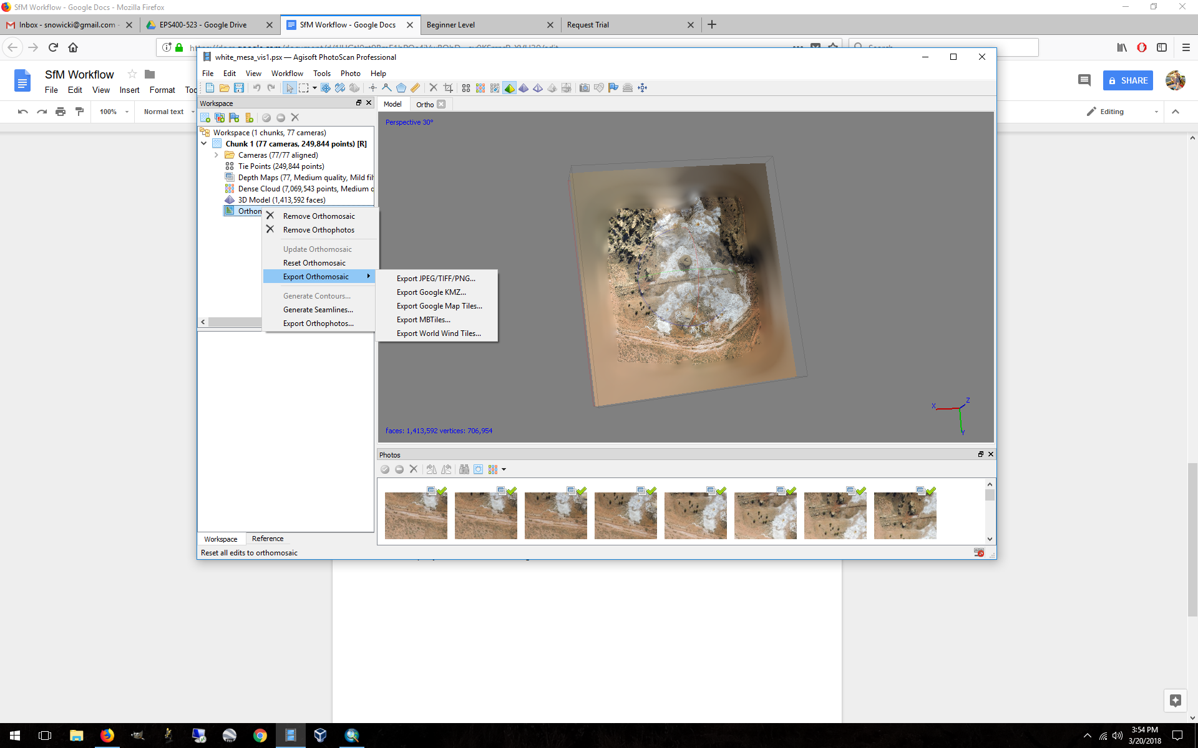

For spectral imagery (Micasense) there is an additional step of exporting the proper raster transform to get true reflectance values. See [MicaSense RedEdge MX processing workflow (including Reflectance Calibration) in Agisoft Metashape Professional : Helpdesk Portal (freshdesk.com)](https://agisoft.freshdesk.com/support/solutions/articles/31000148780-micasense-rededge-mx-processing-workflow-including-reflectance-calibration-in-agisoft-metashape-pro).